Client-Server Architecture
# Source: AI Source: Provided by: [Data Path: Persons Table -> ID Column: 1, Name_En Column: Motasem Essam] -> From: [ChatGPT] on [1/23/2026]
Client-Server Architecture separates a system into two main components:
- Client (Frontend) – Requests services or data
- Server (Backend) – Processes requests and provides responses
👉 Think of it like a restaurant: the client is the customer placing an order, and the server is the kitchen preparing it.

🔑 Key Points
# Source: AI Source: Provided by: [Data Path: Persons Table -> ID Column: 1, Name_En Column: Motasem Essam] -> From: [ChatGPT] on [1/23/2026]
- Clear separation between user interface and business logic
- Client communicates with server over a network
- Server can serve multiple clients simultaneously

🧱 Structure Example
# Source: AI Source: Provided by: [Data Path: Persons Table -> ID Column: 1, Name_En Column: Motasem Essam] -> From: [ChatGPT] on [1/23/2026]
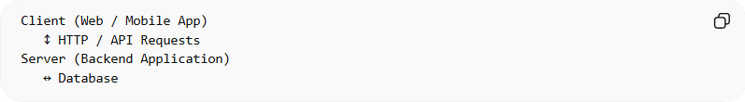
Client (Web / Mobile App)
↕ HTTP / API Requests
Server (Backend Application)
↔ Database
- Client → React frontend, mobile app, or desktop app
- Server → Handles business logic, database access, authentication

❌ Common Problems (Bad Practice)
# Source: AI Source: Provided by: [Data Path: Persons Table -> ID Column: 1, Name_En Column: Motasem Essam] -> From: [ChatGPT] on [1/23/2026]
- Tight coupling between client and server
- Direct database access from client
- Server becomes a bottleneck if not designed for scalability
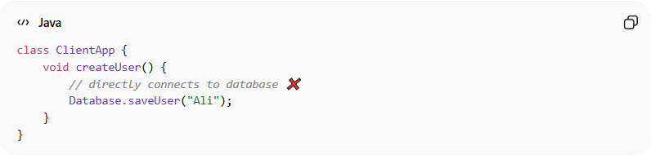
class ClientApp {
void createUser() {
// directly connects to database ❌
Database.saveUser("Ali");
}
}

✅ Benefits (Good Practice)
# Source: AI Source: Provided by: [Data Path: Persons Table -> ID Column: 1, Name_En Column: Motasem Essam] -> From: [ChatGPT] on [1/23/2026]
- Supports multiple clients with one backend
- Business logic centralized on the server
- Easier to update backend without changing clients
- Standard architecture for web and mobile apps
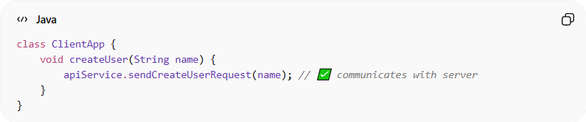
class ClientApp {
void createUser(String name) {
apiService.sendCreateUserRequest(name); // ✅ communicates with server
}
}

⚡ When to Use
# Source: AI Source: Provided by: [Data Path: Persons Table -> ID Column: 1, Name_En Column: Motasem Essam] -> From: [ChatGPT] on [1/23/2026]
- Web applications
- Mobile applications
- Systems where multiple clients need to access the same data
- Projects needing a centralized backend for business rules

